Software Design Document (SDD)

Project name: SPS
Author : Trung Le (000937494)

Project Contact:
Name: Trung Le
Email: xd.letrung@gmail.com
Tel.: 0466579646

Revision History:
Version | Date | Author(s) | Change Description
1.0 | 23/6/2017 | Trung Le | First version of web page  Still missing some points  Connect and work very well with local server

Table of Contents
1 Project overview 4
1.1 Definitions & Acronyms 4
1.2 Project name 5
1.3 System Overview 5
1.4 System Objectives 5
1.8 Scope 5
1.8.1 Document Scope 5
1.8.2 Product Scope 5
2 System Architecture 6
2.1 Design Rationale 6
2.1.1 Three-Tier Architecture 6
2.2 Design Decisions 7
3 Presentation Layer 9
3.1 User Interface Design 9
3.2 Site Map 9
3.2.1 Main Storyboard 9
3.2.2 Other Storyboards 9
4 Application Logic Layer 10
4.1 Structure chart/Event Diagrams 10
4.2 Use Case Diagram 10
5 Data Layer 11
5.1 Entity-Relationship Diagram 11
5.2 System Database Schema 12
6 Functional Requirement Testing 13
7 References 15
8 Sign-off 16
8.1 Client Sign-off 16

Project overview

This section is designed to give an overview of the project.

Definitions & Acronyms
The following definitions and acronyms are used throughout this Document (Software Design Document) they may refer to terms used by the client or by the development team.

Term | Meaning
PM | Project Manager
SPMP | Software Project Management Plan
SRS | Software Requirements Specification
SDD | Software Design Document
UD | User Documentation
PHP | Hypertext Pre-Processor

Project overview
PSP an online-store website which sales audio devices such as headphones, earphones, speaker, music player device, …

System Objectives
- Register/ login membership
- Browsing available items to buy (By searching, sorting product by name or price
- Add items to cart
- Check out with security payment.

Scope

Document Scope
The scope of this document is to outline and describe the design and implementation of AmazingSound from a technical and development perspective. This document outlines a textual model of the application to provide developers with clear guidance in the development phase.
This document is divided into components to outline the key areas of the application. This document will primarily be used by the development team to build the application in accordance with the requirements outlined in the SRS. It may be used, in full or part, to assist in explaining the final design of the application to the client and approval of the final design of the application, as well as serve as the basis for any desired changes.
The broad structure and key areas of this document is as follows:
- Introduction
- System Architecture
- Presentation Layer
- Application Logic Layer
- Data Layer
  - Appendices

Product Scope
The scope of the product has been outlined in the SRS.

System Architecture

Design Rationale
All parts of AmazingSound will use the Three-Tier Architecture approach for various reasons. These reasons are detailed below:

2.1.1 Three-Tier Architecture
The three-tier architecture will be used because of its capability to support hundreds of users, making it more scalable and durable than the two tier architecture model. Three tier architectures assists software development because each tier can be built and executed on a separate platform, thus making it easier to organize the implementation. Three tier architectures also allows different tiers to be developed in different languages, such as HTML for the top tier; PHP for the middle tier; and SQL for the database tier.
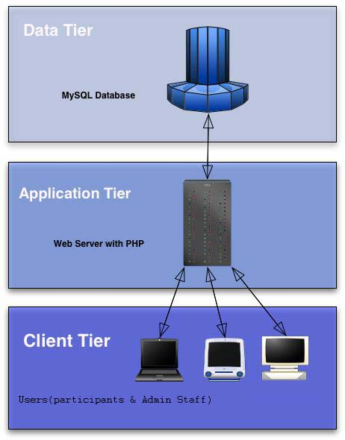
Data Layer
(Data Storage)
Application (Logic) Layer
Presentation Layer

Figure 1 – Three–tier architecture (Think Quest, 2005)

2.1.1.1 Data Tier
The first tier is persistent data storage. The underlying technology to implement this layer could be a variety of things including client side server side files or a database. The first tier is usually best satisfied with a database, running either on the web server itself, or easily accessible to the web server.

2.1.1.2 Application Tier
The second tier is the business logic layer also known as the application logic. This is the code for any rules regarding the data stored and generally is the bulk the application. The second tier is composed of a web server running a scripting language providing database access. While this same architecture could use any scripting language this project will be implementing the PHP programming language.

2.1.1.3 Client Tier
The third tier is presentation, enabling users to see the results of the business logic applied to the data stored. The third tier is clearly the browser-application/browser, rendering the output of PHP scripts for the users.

The reference material all claims this approach can support more users than two-tier (client and server) architectures, and that the number of users can grow. The modular design makes it less fragile, basically meaning that if done correctly, users can upgrade their browsers, and the client can upgrade the database server, without breaking the application. Similarly, the business rules can be changed without having to replace all the users' client programs.

Using a database is a common practice when writing something in PHP; using PHP potentially gives the advantages above.

Design Decisions

Decision | Explanation | Advantages
PHP | PHP is a general-purpose server-side scripting language originally designed for Web development to produce dynamic web pages | -PHP is accessible-It's available for free-It's available with documentation in many languages  -There are many support groups, forums, and teams supporting PHP  -There is a wealth of online information regarding PHP  - It's quick to develop in PHP  -A basic PHP script can be created without a firm understanding of programming principals, compilation, and other currently important programming concepts  -PHP is loosely typed, which makes basic scripts much faster to develop with less attention to design  -PHP is flexible  - It runs on many different operating systems  -It can be optimized, even "compiled" for performance closer to that of more established compiled languages
MYSQL | MYSQL database is a web hosting database that is used to store web site information like user information | -Free license-High functionality  -Easy to recovery-Security
HTML | Hyper Text Markup Language (HTML) is the main markup language for web pages. HTML elements are the basic building-blocks of web pages | - -Easy to use  -Loose syntax  -Supported on almost every browser, if not all browsers.  -Widely used; established on almost every website, if not all websites.  -Very similar to XML syntax, which is increasingly used for data storage  -Free  - You need not buy any software  -Easy to learn & code even for novice programmers
Apache | Apache is web server software notable for playing a key role in the initial growth of the World Wide Web | -Firstly It is open source software- It is free.
RAD | Rapid application development is a software development methodology, which involves iterative development and the construction of prototypes. It is a merger of various structured techniques, especially the data driven Information Engineering with prototyping techniques to accelerate software systems development | -Flexible and adaptable to changes.
StarUML | StarUML is an open source project to develop fast, flexible, extensible, featureful, and freely-available UML/MDA platform | It is open source software and easy to use.

Presentation Layer
This section outlines the design elements of the website which will be presented to the users.

User Interface Design
The Graphical User Interface (GUI) for AmazingSound has been designed to meet two distinct system objectives. The first objective is to create a website that can maintain the interest of the target audience (shoppers) and also to create a professional looking website to ensure that the users are confident to involve in e-commerce transactions.

Site Map
The site map below displays the various pages included in the site
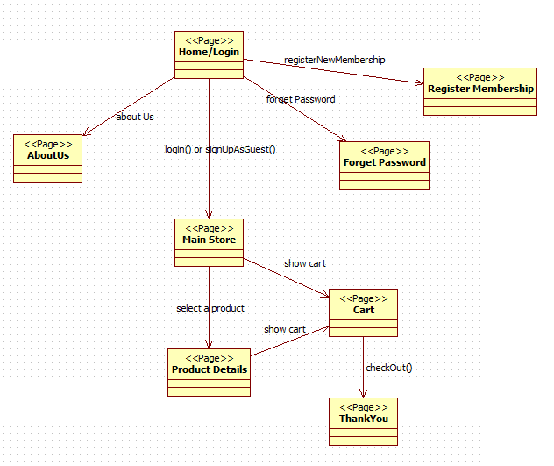

Main Storyboard
Header
Footer
Main Content
The main layout will be used for the majority of the pages within AmazingSound. The layout adheres to a familiar style commonly used throughout the internet. A navigation bar located on the left hand side of the page. A page title/banner along the top including the logo located in the left of the banner. The layout below is designed for use by users with low screen resolutions of 800 pixels wide by 600 high pixels.

Application Logic Layer

This section details the functions that will be created for AmazingSound and how they will operate to meet the project requirements.

Use Case Diagram
This section demonstrates certain functions of the designed solution using high level use case diagrams. Identify the use-cases for the given project speciation and describe the actors and the procedure similar to the example given below.
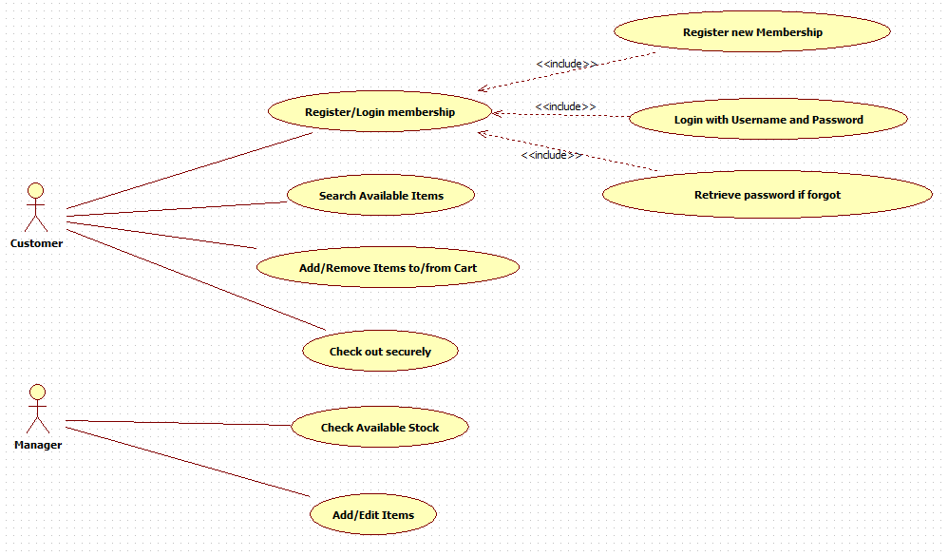

Data Layer
This section outlines the tables, relationships and the way in which the application interacts with the database.

Entity-Relationship Diagram

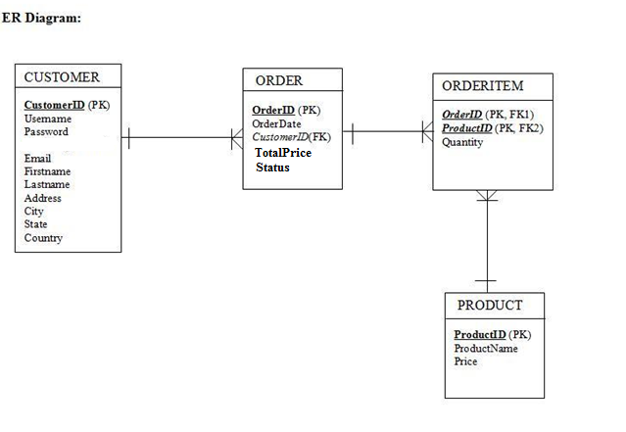
Database Assumptions
- A customer can have many orders.
- An order can have many products (order items).
- A product can appear in many orders therefore we need to split this many to many relationship to have another entity called Order Item.

System Database Schema

Table Name | Column Name | Data Type | Description
CUSTOMER | customerID  firstName  lastName  email/username  password  phoneNum  address  city  postcode | Varchar(10)  Varchar(20)  Varchar(50)  Varchar(50)  Varchar(50)  Varchar(15)  Varchar(50)  Varchar(20)  Integer | Primary key , Auto Increment
PRODUCT | productID  productName  availableStock  price  description | varchar(10)  varchar(50)  integer  decimal (10,2)  varchar(100) | Primary key
ORDER | orderID  orderDate  customerID  totalPrice  note | varchar(10)  date  varchar(10)  decimal (10,2)  varchar(50) | Primary key  Foreign key reference to Customer
ORDERITEM | orderID  productID  quantity | varchar(10)  varchar(10)  integer | Primary key, Foreign key reference to Order  Primary key, Foreign key reference to Product

Functional Requirement Testing

Test case id | Test case description and reason | Data input /  Test procedure | Expected result | Actual result | Pass / Fail
TC001 | Login as Guest | Click ‘SignIn as Guest’ from login page | Can see list of items but not able to make purchase | The system operated as expected. | Pass
TC002 | Log In  Non-signup account  Admin account  User account | An account hasn’t signed up yet  An account has signed up with admin privilege  An account has signed up with user privilege | Login Fail  Login Success – Forward to product page  Login Success – Forward to main page | The system operated as expected. | Pass
TC003 | Add new product | Input data for new product | New product will show up in the list on main page/ save in database  Available to purchase with an user account | The system operated as expected. | Pass
TC004 | Search | From product page (admin mode)  From main page (user mode) | Input key words, list of relative items will appear | The system operated as expected. | Pass
TC005 | Check cart | Add item to cart  - Once  - Multiple times | The shopping list is saved  The shopping list is appended and saved | The system operated as expected. | Pass
TC006 | Check Out | Make an purchase, view cart and check out | Cart shows all the items have been added  After checkout the database must be saved | The system operated as expected. | Pass

References

Websites:
Think Quest (2005) Three tier web applications. Retrieved May 23rd, 2007 from http://www.tqnyc.org/tutorial/three_tier/index.php?s

Sign-off

Client Sign-off

By signing this document I hereby accept and acknowledge that the design solution offered in this Software Requirements Specification will meet the goals of the website.

Client Name: …………………………………

Signature: …………………………………

Date: …………………………………

